|  |
| --- |
| **D:\CE\WhatsApp Image 2021-05-08 at 4.35.03 PM.jpeg**    ***“CULTIVATING EXCELLENCE IN EVERY STUDENT”***  **‘**  **RAKESH KUMAR**  **M.Sc. (Chemistry) B.Ed.**  **CTET, PSTET, HPTET qualified**  **thakurkumar82@gmail.comA taste of technology | News Centre - Official news site of Calderdale  Councilhttp://chemistryexpert.in/** |
| **Class:-XII (Sci.) Name of Student……………………**  **Subject:- Chemistry**  **Work Sheet-1**  **Chapter-11**  **Alcohols, Phenols & Ethers** |

**Q.1** Preparation of ethers by acid dehydration of secondary or 30 alcohols is not a suitable method?

**Q.2** Ortho‐nitro phenol is more acidic than ortho –methoxyphenol? Why?

**Q.3** While separating a mixture of ortho and paranitrophenols by steam distillation, name the isomer which will be steam volatile. Give reason.

**Q.4** Explain why is orthonitrophenol more acidic than orthomethoxyphenol?

**Q.5** What is meant by hydroboration‐oxidation reaction? Illustrate it with an example.

**Q.6** Give the equations of reactions for the preparation of phenol from cumene.

**Q.7** How is aspirin (Acetylsalicylic acid) prepared from salicylic acid?

**Q.8** Diethyl ether does not react with sodium. Explain.

**Q.9** Give two reactions that show the acidic nature of phenol. Compare acidity of phenol with that of ethanol.

**Q.10**How does phenol reacts with Br2 in CS2 and Bromine water?

**Q.11** Give reasons: i) Nitration of phenol gives ortho- and para- products only.

ii) Why do alcohols have higher boiling points than the haloalkanes of the same molecular mass?

iii) Acid catalysed dehydration of tert. Butyl alcohol is faster than that of n-butyl alcohol.

**Q.12** Explain the fact that in aryl alkyl ethers;

(i) The alkoxy group activates the benzene ring towards electrophilic substitution and

(ii) It directs the incoming substituents to ortho and para positions in benzene ring.

**Q.13** Give equations of the following reactions: (i) Oxidation of propan-1-ol with alkaline KMnO4 solution. (ii) Bromine in CS2 with phenol. (iii) Dilute HNO3 with phenol.

**Q.14** How are the following conversions carried out?

(i) Propene → Propan-2-ol (ii) Benzyl chloride → Benzyl alcohol

(iii) Ethyl magnesium chloride → Propan-1-ol. (iv) Ethanal to ethanol (v) Phenol to ethoxybenzene (vi) 1-phenylethene to 1-phenylethanol (vii) Formaldehyde to cyclohexylmethanol

(viii) Butyl bromide to pentan-1-ol. (ix) Toluene to benzyl alcohol (x) 1-propoxypropane to propyl iodide (xi) Ethyl bromide to 1-ethoxyethane (xii) Methyl bromide to 2-methoxy-2-methylpropane (xiii) Ethyl bromide to ethoxybenzene (xiv) Ethanol to benzyl ethyl ether.

(xv) Phenol to salicylic acid. (xvi) ethene to divinyl ether.

**Q.15** How is 1-propoxypropane synthesised from propan-1-ol? Write mechanism of this reaction.

**Q.16**Describe the following reactions with example:

(i) Hydroboration oxidation of alkenes (ii) Acid catalysed dehydration of alcohols at 443K.

(iii) Williamson synthesis (iv) Reimer-Tiemann reaction. (v) Kolbe’s reaction

(vi) Friedel-Crafts acylation of Anisole.

**Q.17**Give a chemical test to distinguish between the following pair of compounds.

(i) n-propyl alcohol and isopropyl alcohol (ii) methanol and ethanol (iii) cyclohexanol and phenol.

(iv) propan-2-ol and 2-methylpropan-2-ol. (v) phenol and anisole (vi) ethanol and diethyl ether.

**Q.18**What happens when: (i) aluminium reacts with tert-butyl alcohol (ii) phenol is oxidised with chromic acid (iii) cumene is oxidised in the presence of air and the product formed is treated with dilute acid. (iv) Phenol is treated with conc. HNO3. (v) Phenol is treated with chloroform in presence of dilute NaOH.

**Q.19** What is the function of ZnCl2 (anhyd.) in Lucas test for distinction between 1°, 2° and 3° alcohols.

**Q.20** An alcohol A (C4H10O) on oxidation with acidified potassium dichromate gives carboxylic acid B (C4H8O2). Compound A when dehydrated with conc. H2SO4 at 443 K gives compound C. Treatment of C with aqueousH2SO4 gives compound D (C4H10O) which is an isomer of A. Compound D is resistant to oxidation but compound A can be easily oxidised. Identify A, B, C and D and write their structures.

**Q.21** An organic compound A having molecular formula C6H6O gives a characteristic colour with aqueous FeCl3. When A is treated with NaOH and CO2 at 400 K under pressure, compound B is obtained. Compound B on acidification gives compound C which reacts with acetyl chloride to form D which is a popular pain killer. Deduce the structure of A, B, C and D. What is the common name of Drug D.

**Q.22**An ether A (C5H12O) when heated with excess of hot concentrated HI produced two alkyl halides which on hydrolysis from compounds B and C. Oxidation of B gives an acid D whereas oxidation of C gave a ketone E. Deduce the structures of A, B, C, D and E.

**Q.23**Phenol, C6H5OH when it first reacts with concentrated sulphuric acid, forms Y.Y is reacted with concentrated nitric acid to form Z. Identify Y and Z and explain why phenol is not converted commercially to Z by reacting it with conc. HNO3.

**Q.24** Identify X, Y and Z in the following sequence of reactions:

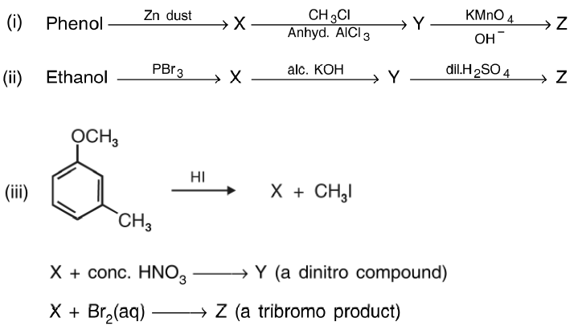

**Q.25** Identify the missing reactant or product A to D in the following equations:

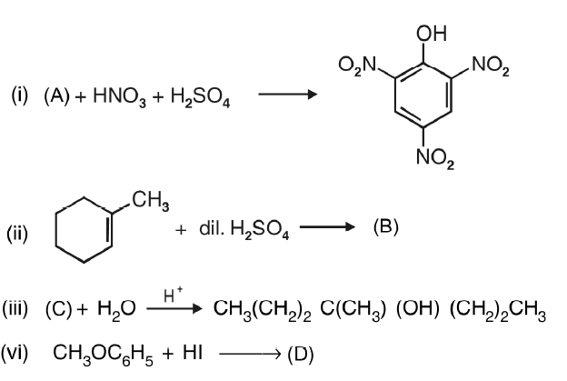

**Q.26** Complete the following reactions:



